Task-6

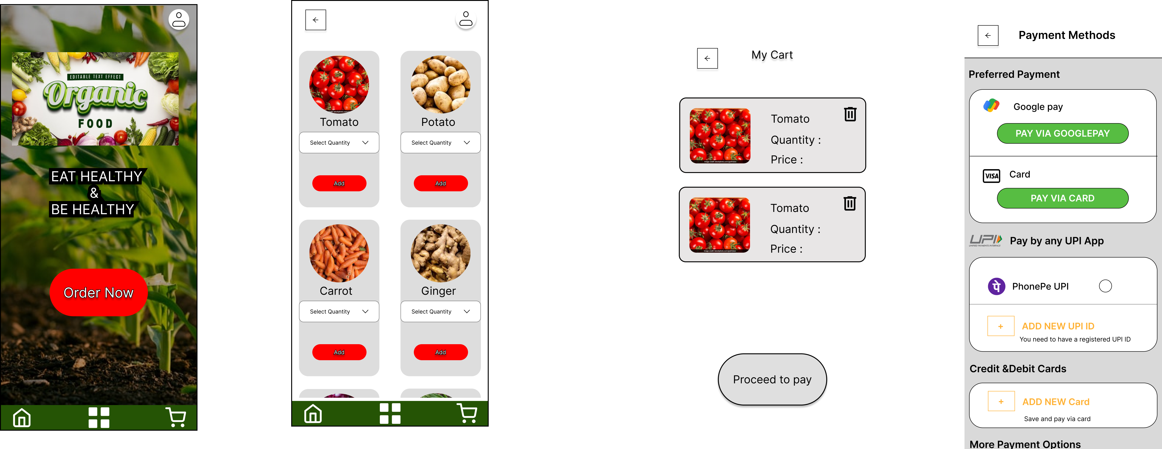

I had conducted 3 user interview for my fresh bite application. The feedback they gave was

* The UI is very simple and the there is no proper alignment
* The icons sizes are different
* There is no proper color for buttons

From the user feedback I had changed all my design by adding grids, some button colors etc.

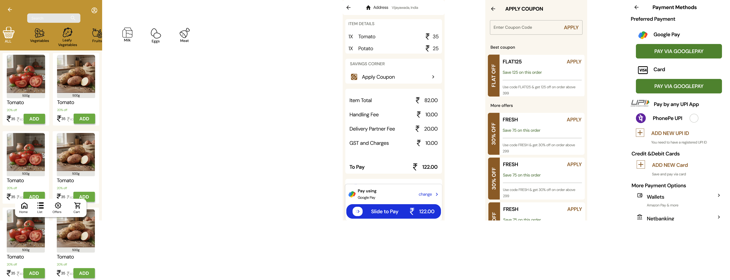

Figma:

https://www.figma.com/design/0QeD2QAGsuzneeimEEfctB/Elevate-labs?node-id=79-366&t=fRM4vP6ccwTqBUGU-1